**Corporate PROFILE**

**Your Valuation, Property and Facilities Management, Asset Coding, Survey, Land and Real Estate Consultancy, Resettlement Action Plan and Social Performance Business Partner**

Who We Are

**NASIA CONSULT LIMITED** is the Limited Company with limited liability incorporated under cap 212 of the laws of the United Republic of Tanzania and CAP No. 12 of 2012 Zanzibar. The Company is duly registered and was issued with a Certificate of incorporation No. **136410** on 12th day of July, 2017 Tanzania Main land and No. Z0000132653 Zanzibar on 30th November 2021 with business license, TIN andVAT Certificates all under the name of **NASIA CONSULT CO. LIMITED.**

**NASIA CONSULT LIMITED** is reputable, qualified and experienced in the field **of Property and Facilities Management, Asset Valuation, Asset Physical Verification, Asset Coding, Property Finance and Marketing, General Auctioning, Mortgage Broker, Real estate agent, Debt collection, Survey, Resettlement Plan, Land and Real Estate Consultancy.** To supplement its consultancy services, **NASIA CONSULT** also outsources services of other independent specialists from the general public as and when needed for such multidisciplinary approach arises.

**Vision**

The vision of NASIA CONSULT CO. LIMITED, Company is to achieve the highest possible standards of the real estate market while establishing our agency as the premier and preferred real estate company in Africa.

**Mission**

“To provide an outstanding level of service and expertise in the real estate market that is innovative and ambitious”

COMPLIANCE TO THE PROFESSIONAL STANDARDS AND BOARDS

**LOCAL COMPLIANCE**

* Valuers Registration Board **(VRB)**
* Board of Valuers Zanzibar **(BVZ)**
* National Board of Accountants and Auditors**(NBAA)**
* Procurement and Supplies Professionals and Technicians Board **(PSPTB)**
* Public Asset Management Guidelines **(PAMG)**
* Association of Real Estate Professionals of Tanzania **(AREPTA)**
* Association of Real Estate **(AREA)**
* African Real Estate Society **(AFRES)**
* Institute of Surveyors Tanzania **(IST).**
* Tanzania Revenue Authority **(TRA)**
* Energy and Water Utilities Regulatory Authority **(EWURA)**
* Occupational Safety and Health Administration **(OSHA)**

**INTERNATIONAL COMPLIANCE**

* International Valuation Standard **(IVS)**
* International Financial Reporting Standard **(IFRS)**
* International Public Sector Accounting Standard **(IPSAS)**
* Royal Institution of Chartered Surveyors (RICS)
* Council for Mining and Metals **(ICMM)**

PROFESSIONAL KEY PERSONEL

* **FRV. HAMISI M. LYOBA –** Fully Registered Valuer under Valuers Registration Board (VRB), Masters in Real Estate, Advanced Diploma in Land Management and Valuation; Over 15 years’ experience in Property, Plant and Machinery Valuation, Property and Facilities Management, Asset Coding and Management, Land cadastral, Land and Real Estate Consultancy. Member of Association of Real Estate Professionals of Tanzania (AREPTA)
* **FRV. ATUFIGWEGE A. MWAIPOPO** - Fully Registered Valuer under Valuers Registration Board (VRB), Masters in Real Estate, Advanced Diploma in Land Management and Valuation; Over 15 years’ experience in Property, Plant and Machinery Valuation, Property and Facilities Management, Asset Coding and Management, Land cadastral, Land and Real Estate Consultancy. Member of Association of Real Estate Professionals of Tanzania (AREPTA)
* **FRV. ZAKARIA T. KIDUKO** - Fully Registered Valuer under Valuers Registration Board (VRB), Masters in Real Estate, Advanced Diploma in Land Management and Valuation; Over 15 years’ experience in Property, Plant and Machinery Valuation, Property and Facilities Management, Asset Coding and Management, Land cadastral, Land and Real Estate Consultancy. Member of Association of Real Estate Professionals of Tanzania (AREPTA)
* **FRV. PAULINA R**. **SONGELAELI** - Fully Registered Valuer under Valuers Registration Board (VRB), Bachelor Degree in Land Management and Valuation; Over 15 years’ experience in Property, Plant and Machinery Valuation, Property and Facilities Management, Asset Coding and Management, Land cadastral, Land and Real Estate Consultancy. Member of Association of Real Estate Professionals of Tanzania (AREPTA)
* **FRV. JIMMY BARTON** - Fully Registered Valuer under Valuers Registration Board (VRB), Bachelor Degree in Land Management and Valuation; Over 15 years’ experience in Property, Plant and Machinery Valuation, Property and Facilities Management, Asset Coding and Management, Land cadastral, Land and Real Estate Consultancy. Member of Association of Real Estate Professionals of Tanzania (AREPTA)

Our consultancy services

**NASIA** offers consultancy services in the following disciplines:

1. **PROPERTY AND FACILITIES MANAGEMENT**
2. **VALUATION (FIXED & MOVABLE ASSET)**
3. **FIXED ASSET CODING, UPDATING FIXED ASSET REGISTER**
4. **LAND AND REAL ESTATE CONSULTANCY**

**PROPERTY AND FACILITIES MANAGEMENT**

Our department advises organizations on the planning and best use and management of the real estate holding including, Real Estate, Policy Formation refurbishment, tenancy and lease structure, rent collection and general maintenance and management of multi-tenanted office complexes, residential estates as well as variety of other types of properties.

**VALUATION (FIXED & MOVABLE ASSET)**

To value virtually all types of assets for sale purpose, rent determination, insurance, mortgage, probate, financial reporting (Balance sheet/Accounting Purposes) compensation, stock exchange floatation, Property Taxation or rating.

**FIXED ASSET CODING, UPDATING FIXED ASSET REGISTER**

Asset Management System (Asset Coding, Asset Audit/Reconciliation, Update Fixed Asset Register, supply of Mobile barcode scanners/readers, printer and Asset Management Software.

**LAND AND REAL ESTATE CONSULTANCY**

Under this service NASIA takes part in the acquisition of Title Deeds, carries Title deed search, Land Registration, conveyance/transfer of Land ownership, conversion and variation of Land Use and miscellaneous Land Advisory services.

We also deal with site acquisitions and advise clients on suitability of selected sites for particular use or development.

**On Land Administration issues, we do the following:**

• Land surveying

• Apply for letter of offer on behalf of clients

• Process the registration and issuance of Certificate of Title Deeds for our clients.

• Renewal of expired Right of occupancy

• Processing of change of Land use

To sell, buy and let of properties on behalf of the clients and also provide Professional advice relating to the buying and letting of properties, e.g. Legality of title, tax implications, structural and aesthetic condition of a property, current market value, future marketability of the property etc.

EXPERIENCE AND CURRENT PROJECTS

**PROPERTY MANAGEMENT**

|  |  |  |
| --- | --- | --- |
| **S/N** | **PROJECT** |  |
| **1.** | **OSHA BUILDING DODOMA TANZANIA** |  |
| **2.** | **NSSF AKIBA HOUSE IRINGA, TANZANIA** |  |
| **3.** | **NSSF MAFAO HOUSE MBEYA, TANZANIA** |  |
| **4.** | **NSSF MBOZI COMMERCIAL BUILDING, TANZANIA** |  |
| **5.** | **NSSF COMPLEX COMMERCIAL BUILDING NJOMBE, TANZANIA** |  |
| **6.** | **NSSF AKIBA HOUSE SONGEA, TANZANIA** |  |
| **7.** | **NSSF GANGILONGA FLATS, TANZANIA** |  |
| **8.** | **NSSF PAWAGA FLATS, TANZANIA** |  |
| **9.** | **NSSF PAWAGA FLATS, TANZANIA** |  |
| **10.** | **PSSSF MIKOCHENI APARTMENT, TANZANIA** |  |
| **11.** | **PSSSF MASAKI APARTMENT, TANZANIA** |  |
| **12.** | **PSSSF KIJITONYAMA APARTMENT, TANZANIA** |  |
| **13.** | **PSSSF KALOLENI APARTMENT, ARUSHA-TANZANIA** |  |
| **14.** | **PSSSF JACARANDA APARTMENT, ARUSHA- TANZANIA** |  |
| **15.** | **PSSSF QUALITY CENTRE DAR ES SALAAM** |  |

**VALUATION (FIXED AND MOVABLE ASSETS), ASSET CODING AND UPDATING ASSET REGITER**

|  |  |  |
| --- | --- | --- |
| **S/N** | **Name of Employer and Full Address** | **Type Of Services Provided** |
| 1. | **D:\Office\2.NASIA CONSULT LTD\7.Tenders\3.BANKS\38.Alliance Finance Limited\Company Profile\download.jpg**  **MINISTRY OF HEALTHY** | * Asset Physical Verification * Asset Coding * Inventory Control Card/ Sheet and * Inventory Master Boon * Asset Valuation * Asset Register (Review/Update/   Reconciliation/Audit) and Supply of  barcode scanner/reader |
| 2. | **CENTRE FOR FOREIGN RELATION (CFR)** | * Asset Physical Verification * Asset Coding * Inventory Control Card/ Sheet and * Inventory Master Boon * Asset Valuation * Asset Register (Review/Update/   Reconciliation/Audit) and Supply of  barcode scanner/reader |
| 3 | Image for post  **CHAMA CHA MAPINDUZI** | * Asset Physical Verification * Asset Coding * Inventory Control Card/ Sheet and * Inventory Master Boon * Asset Valuation * Asset Register (Review/Update/   Reconciliation/Audit) and Supply of  barcode scanner/reader |
| 4 | **D:\Office\2.NASIA CONSULT LTD\7.Tenders\3.BANKS\38.Alliance Finance Limited\Company Profile\download.jpg**  **MWANANYAMALA HOSPITAL** | * Asset Physical Verification * Asset Coding * Inventory Control Card/ Sheet and * Inventory Master Boon * Asset Valuation * Asset Register (Review/Update/   Reconciliation/Audit) and Supply of  barcode scanner/reader |
| 5 | **D:\Office\2.NASIA CONSULT LTD\7.Tenders\3.BANKS\38.Alliance Finance Limited\Company Profile\download (1).jpg**  **MUHIMBILI ORTHOPAEDIC INSTITUTE (MOI)** | * Asset Physical Verification * Asset Coding * Inventory Control Card/ Sheet and * Inventory Master Boon * Asset Valuation * Asset Register (Review/Update/   Reconciliation/Audit) and Supply of  barcode scanner/reader |
| 6 | **D:\Office\2.NASIA CONSULT LTD\3.Barcodes\29.KCMUCO\download.png**  **KILIMANJARO CHRISTIAN MEDICAL UNIVERSITY COLLEGE** | * Asset Physical Verification * Asset Coding * Inventory Control Card/ Sheet and * Inventory Master Boon * Asset Valuation * Asset Register (Review/Update/   Reconciliation/Audit) and Supply of  barcode scanner/reader |
| 7 | **D:\Office\2.NASIA CONSULT LTD\7.Tenders\3.BANKS\38.Alliance Finance Limited\Company Profile\download.jpg**  **MAZIMBU HOSPITAL** | * Asset Physical Verification * Asset Coding * Inventory Control Card/ Sheet and * Inventory Master Boon * Asset Valuation * Asset Register (Review/Update/   Reconciliation/Audit) and Supply of  barcode scanner/reader |
| 8 | **D:\Office\2.NASIA CONSULT LTD\7.Tenders\3.BANKS\38.Alliance Finance Limited\Company Profile\download.jpg**  **MOROGORO REGIONAL REFERRAL HOSPITAL** | * Asset Physical Verification * Asset Coding * Inventory Control Card/ Sheet and * Inventory Master Boon * Asset Valuation * Asset Register (Review/Update/   Reconciliation/Audit) and Supply of  barcode scanner/reader |
| 9 | **GEPF** | * Asset Physical Verification * Asset Coding * Inventory Control Card/ Sheet and * Inventory Master Boon * Asset Valuation * Asset Register (Review/Update/   Reconciliation/Audit) and Supply of  barcode scanner/reader |
| 10 | **ZANZIBAR TELECOM LTD (ZANTEL)** | * Asset Physical Verification * Asset Coding * Inventory Control Card/ Sheet and * Inventory Master Boon * Asset Valuation * Asset Register (Review/Update/   Reconciliation/Audit) and Supply of  barcode scanner/reader |
| 11 | **TANZANIA INVESTMENT CENTRE (TIC)** | * Asset Physical Verification * Asset Coding * Inventory Control Card/ Sheet and * Inventory Master Boon * Asset Valuation * Asset Register (Review/Update/   Reconciliation/Audit) and Supply of  barcode scanner/reader |
| 12 | **CELLULANT CORPORATION** | * Asset Physical Verification * Asset Coding * Inventory Control Card/ Sheet and * Inventory Master Boon * Asset Valuation * Asset Register (Review/Update/   Reconciliation/Audit) and Supply of  barcode scanner/reader |
| 13 | **SUMAJKT** | * Asset Physical Verification * Asset Coding * Inventory Control Card/ Sheet and * Inventory Master Boon * Asset Valuation * Asset Register (Review/Update/   Reconciliation/Audit) and Supply of  barcode scanner/reader |
| 14 | **MYOCHIKAI ARIGATORI FOUNDATION** | * Asset Physical Verification * Asset Coding * Inventory Control Card/ Sheet and * Inventory Master Boon * Asset Valuation * Asset Register (Review/Update/   Reconciliation/Audit) and Supply of  barcode scanner/reader |
| 15 | **MKWAWA UNIVDERSITY COLEDGE OF EDUCATION** | * Asset Physical Verification * Asset Coding * Inventory Control Card/ Sheet and * Inventory Master Boon * Asset Valuation * Asset Register (Review/Update/   Reconciliation/Audit) and Supply of  barcode scanner/reader |
| 16 | **ST. THOMAS AQUINAS SECONDARY SCHOOL** | * Asset Physical Verification * Asset Coding * Inventory Control Card/ Sheet and * Inventory Master Boon * Asset Valuation * Asset Register (Review/Update/   Reconciliation/Audit) and Supply of  barcode scanner/reader |
| 17 | **SCHOOL OF ST. JUDE** | * Asset Physical Verification * Asset Coding * Inventory Control Card/ Sheet and * Inventory Master Boon * Asset Valuation * Asset Register (Review/Update/   Reconciliation/Audit) and Supply of  barcode scanner/reader |
| 18 | **KARIAKOO MARKET CORPORATION** | * Asset Physical Verification * Asset Coding * Inventory Control Card/ Sheet and * Inventory Master Boon * Asset Valuation * Asset Register (Review/Update/   Reconciliation/Audit) and Supply of  barcode scanner/reader |
| 19 | **4**  **The International Container Terminal Building Dar es Salaam Port (TICTS)** | * Asset Physical Verification * Asset Coding * Inventory Control Card/ Sheet and * Inventory Master Boon * Asset Valuation * Asset Register (Review/Update/   Reconciliation/Audit) and Supply of  barcode scanner/reader |
| 20 | **LogoNATIONAL SECURITY SOCIAL FUND** | * Asset Physical Verification * Asset Coding * Inventory Control Card/ Sheet and * Inventory Master Boon * Asset Valuation * Asset Register (Review/Update/   Reconciliation/Audit) and Supply of  barcode scanner/reader |
| 21 | **download**  **AFRICAN MINERALS AND GEOSCIENCE CENTRE** | * Asset Physical Verification * Asset Coding * Inventory Control Card/ Sheet and * Inventory Master Boon * Asset Valuation * Asset Register (Review/Update/   Reconciliation/Audit) and Supply of  barcode scanner/reader |
| 22 | **download (1)**  **COLLEGE OF AFRICAN WILDLIFE MANAGEMENT, MWEKA** | * Asset Physical Verification * Asset Coding * Inventory Control Card/ Sheet and * Inventory Master Boon * Asset Valuation * Asset Register (Review/Update/   Reconciliation/Audit) and Supply of  barcode scanner/reader |

**EXPERIENCE IN WORKING WITH FINANCIAL INSTITUTIONS/ BANKS**

|  |  |  |
| --- | --- | --- |
| **S/N** | **Name of Bank** | Title and Name of Contact Person |
| 1. | **CRDB BANK** | Property Valuation for Mortgage Purposes |
| 2. | **NMB BANK** | Property Valuation for Mortgage Purposes |
| 3. | **TPB BANK** | Property Valuation for Mortgage Purposes |
| 4. | **TADB BANK** | Property Valuation for Mortgage Purposes |
| 5. | **STANBIC BANK** | Property Valuation for Mortgage Purposes |
| 6. | **TIB BANK**  **D:\Masasi Food Industries\logo1m.png** | Property Valuation for Mortgage Purposes |
| 7. | **MKOMBOZI COMMERCIAL BANK** | Property Valuation for Mortgage Purposes |
| 8. | **AKIBA COMERCIAL BANK (ACB)** | Property Valuation for Mortgage Purposes |
| 9. | **AZANIA BANK LTD,** | Property Valuation for Mortgage Purposes |
| 10. | **TANZANIA COMMERCIAL BANK PLC,**  D:\Val.Case wrk\propertywise\2021\Properties\Ubungo-TPB\PHOTO-2021-07-23-15-34-22.jpg | Property Valuation for Mortgage Purposes |
| 11. | **PEOPLE'S BANK OF ZANZIBAR LIMITED (PBZ)** | Property Valuation for Mortgage Purposes |

WHY US

**Highest Standards of Quality and Performance**All staffs of the Company are bound by:

* A Code of Ethics
* Rules of Conduct
* Professional Practice Standards
* Experience
* High Level of Technology
* Reaserch

**OUR PRECIOUS CLIENTS**

Our services are utilized by a diverse group of clients. Below are examples of our varied client base.

A Wide Range of Clients comes from the following:

* + - * Banks
      * Attorneys
      * Accountant
      * Corporations
      * Government Agencies
      * Individual Homeowners
      * Insurance Companies
      * Lending Institutions
      * Mortgage Brokers
      * Nonprofits Organizations
      * Private Investors
      * Real Estate Developers
      * Schools and Universities
      * And many more

**PROPERTY AND FACILITIES MANAGEMENT**

* Public Service Social Security Fund (PSSSF)
* National Social Security Fund (NSSF)
* Zanzibar Social Security Fund (ZSSF)
* Occupational Safety and Health Administration(OSHA)
* Tanzania Building Agency (TBA)
* National Housing Corporation (NHC)
* Watumishi Housing (WH)
* National Bank of Commerce (NBC)
* National Health Insurance Fund (NHIF)
* Bank of Tanzania (BOT)

**VALUATION (FIXED AND MOVABLE ASSETS), ASSET CODINGB AND UPDATING ASSET REGISTER**

  

**COMPANY CREDENTIALS**

****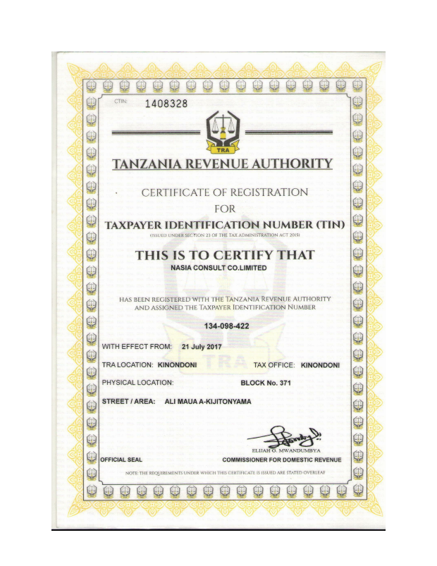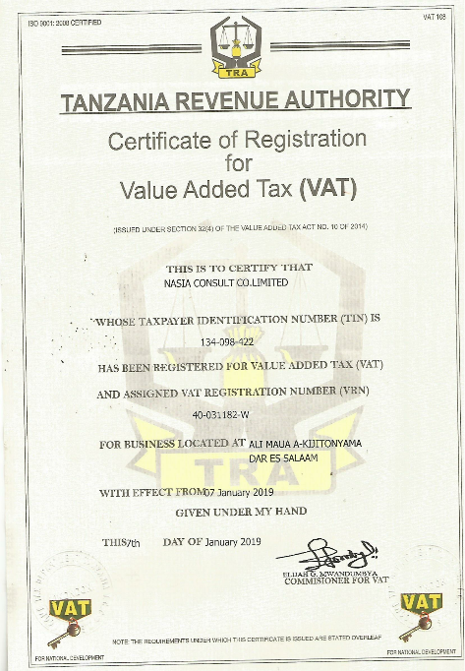

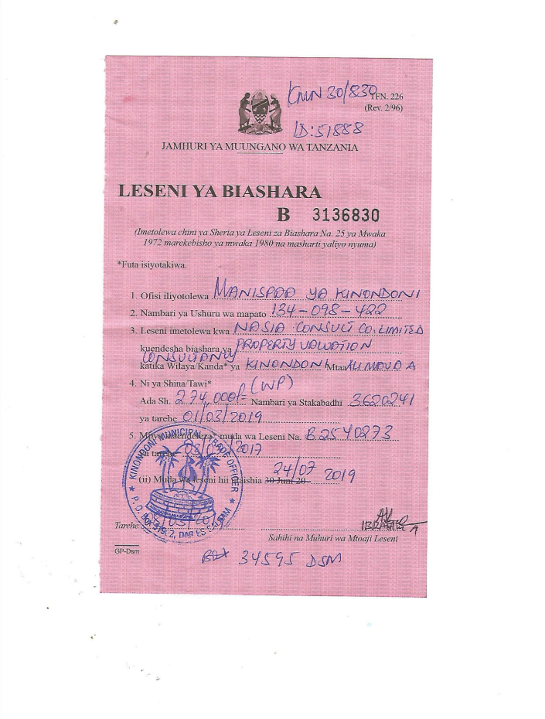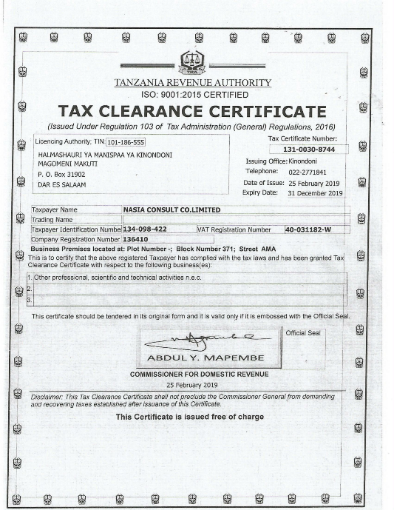

**CONTACTS AND ADDRESS**

|  |
| --- |
| **NASIA CONSULT LTD,**  **Victoria Noble Centre, 04th Floor, Plot No. 89, Bagamoyo Road,**  **P.O. Box 34595, Kijitonyama-Kinondoni, Dar es Salaam.**  **Dar es Salaam.** |